# Describe AI workloads and considerations

## Identify features of common AI workloads

**Question 1: Which scenario is an example of the forecasting AI workload?**

Choose the correct answer

Detecting pedestrians in the real-time video stream of an autonomous vehicle

Detecting the language in the provided text document

Providing answers to a customer in a chatbot dialog

Predicting whether an airplane arrives early, on-time, or late

### Question 2:

Which scenario is an example of the natural language processing AI workload?

Choose the correct answer

Using graphics and menus to improve the user experience with an ecommerce website’s chatbot

Predicting whether a customer would buy certain items based on their purchase history

Analyzing customer feedback on an ecommerce website to determine whether it is positive or negative

Detecting whether people in online-posted images are celebrities

### Question 3:

Which scenario is an example of the conversational AI workload?

Choose the correct answer

Generating automatic descriptions for published images

Predicting whether customers should be targeted by a new marketing campaign

Using a chatbot to answer common customer questions

Extracting key phrases from student essays

### Question 4:

To complete the sentence, select the appropriate option from the drop-down menu.

Choose the correct options

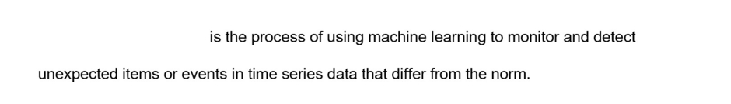

Anomaly detection

Prediction

Knowledge mining

### Question 5:

For each of the following statements, select Yes if the statement is true. Otherwise, select No.

|  |  |  |
| --- | --- | --- |
| **Statement** | **Yes** | **No** |
| Computer Vision can be used to analyze static images. |  |  |
| Computer Vision can be used to analyze live video streams. |  |  |
| Computer Vision can be used to analyze live audio streams. |  |  |

### Question 6:

For each of the following statements about the anomaly detector workload, select Yes if the statement is true. Otherwise, select No.

|  |  |  |
| --- | --- | --- |
| **Statement** | **Yes** | **No** |
| Anomalies can be detected by AI as they occur in real time. |  |  |
| Anomalies can be detected by AI throughout a historical dataset. |  |  |
| Anomaly detection boundaries that are automatically created by AI are immutable. |  |  |

### Question 7:

For which of these scenarios should you use an AI-based prediction solution?

Choose the correct answer

Determining the likely repair costs for an accident involving a vehicle

Detecting abnormal events in a vehicle's engine

Detecting the speed limit using roadside signage

Determining the distance to the vehicle in front

### Question 8:

For each of the following statements about anomaly detection, select Yes if the statement is true. Otherwise, select No.

|  |  |  |
| --- | --- | --- |
| **Statement** | **Yes** | **No** |
| Anomaly detection enables pre-emptive action to be taken before a problem occurs. |  |  |
| Anomaly detection predicts when problems will occur. |  |  |
| Anomaly detection analyzes data over time. |  |  |

### Question 9:

Match the AI workload to the scenario. To answer, drag the appropriate workload to each scenario. A workload may be used once, more than once, or not at all.

Drag and drop the answers

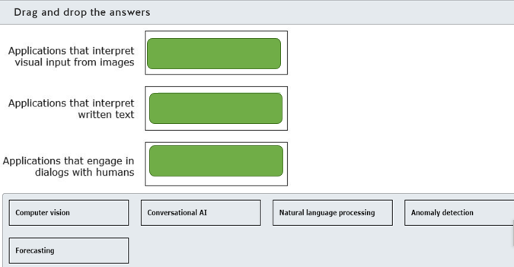

### Question 10:

For which scenario should you use Computer Vision?

Choose the correct answer

Finding relevant information to answer a specific customer question

Translating commands into actions

Detecting abnormalities in health scans

Discovering financial system fraud

### Question 11:

To complete the following sentence, select the appropriate option from the drop-down menu.

Choose the correct options

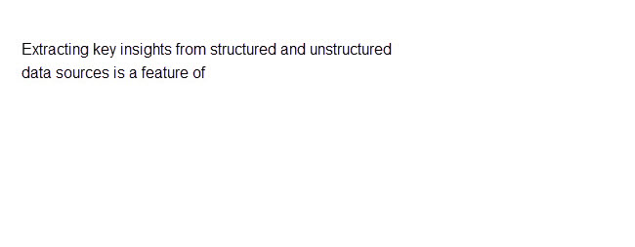

Anomaly detection

Conversational AI

Knowledge mining

The prediction models

### Question 12:

For which two of these scenarios should you use Conversational AI? Each correct answer presents a complete solution.

Choose the correct answers

Translating speech from one language to another.

Making a travel reservation.

Detecting a change in hospital infection rates.

Detecting spam in emails.

Answering frequently asked questions.

### Question 13: Which two guiding principles are part of Microsoft’s responsible AI approach? Each correct answer presents a complete solution.

Choose the correct answers

Simplified Identity Governance

Secure Adaptive Access

Seamless User Experiences

Reliability & Safety

Inclusiveness

### Question 14: A company gives clear explanations of how the banking AI system works and what factors it considers in approving mortgage applications. Which responsible AI principle is this an example of?

Choose the correct answer

Inclusiveness

Accountability

Fairness

Transparency

### Question 15: A company carries out rigorous testing and deployment management of the AI system that powers a driverless taxi solution. This is an example of applying which responsible AI principle?

Choose the correct answer

Inclusiveness

Transparency

Reliability and safety

Accountability

### Question 16: An HR AI system screens job candidates without taking into account personal factors such as age, gender, ethnicity, or physical abilities. This is an example of applying which responsible AI principle?

Choose the correct answer

Inclusiveness

Accountability

Fairness

Transparency

### Question 17: For each of the following statements, select Yes if the statement is true. Otherwise, select No.

|  |  |  |
| --- | --- | --- |
| **Statement** | **Yes** | **No** |
| According to the Transparency principle, AI systems should treat all people fairly. |  |  |
| According to the Reliability & Safety principle, AI systems should be secure and respect privacy. |  |  |
| According to the Accountability principle, people should be accountable for AI systems. |  |  |

### Question 18: To complete the sentence, select the appropriate option from the drop-down menu.

Choose the correct options

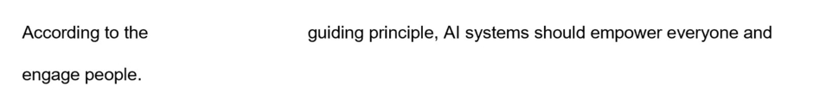

Fairness

Inclusiveness

Transparency

### Question 20: To complete the sentence, select the appropriate option from the drop-down menu.

Choose the correct options

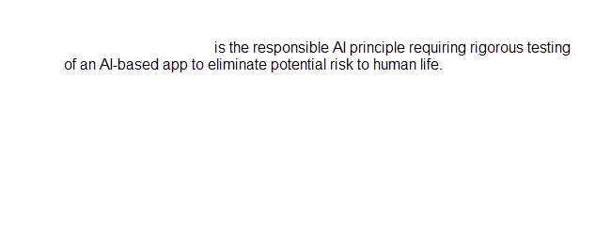

Accountability

Privacy and security

Reliability and safety

### Question 21: Match the Responsible AI principles to the objective. To answer, drag the appropriate principle to each objective. A principle may be used once, more than once, or not at all.

Drag and drop the answers

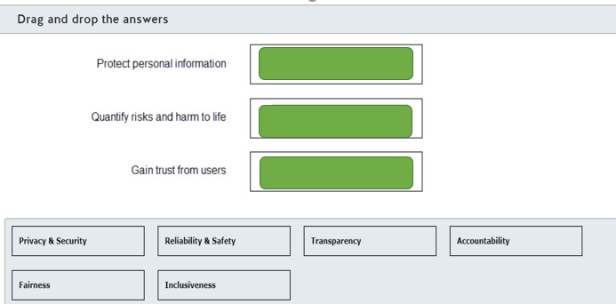

### Question 22: For each of the following statements about inclusiveness, select Yes if the statement is true. Otherwise, select No.

|  |  |  |
| --- | --- | --- |
| **Statement** | **Yes** | **No** |
| Inclusiveness brings the benefits of an AI-based solution to all members of society. |  |  |
| Inclusiveness makes users aware of the purpose and limitations of an AI-based solution. |  |  |
| Inclusiveness is an AI-based solution that empowers and engages all communities in the world. |  |  |

### Question 23: Which responsible AI principle is concerned with making users aware of the limitations of an AI-based system?

Choose the correct answer

Fairness

Transparency

Accountability

Inclusiveness

### Question 24: Which two of these scenarios does the accountability responsible AI principle apply to? Each correct answer presents a complete solution.

Choose the correct answers

Keeping personal details private

Following a governance framework

Operating as expected

Meeting ethical standards

Treating people fairly

# Describe fundamental principles of machine learning on Azure

## Identify common machine learning types

### Question 25: Predicting the online sales volume for the next financial quarter is an example of what machine learning scenario?

Choose the correct answer

Regression

Clustering

Classification

### Question 26: Analyzing X-ray images to detect whether a person has pneumonia is an example of what machine learning scenario?

Choose the correct answer

Classification

Regression

Clustering

### Question 27: Grouping together online shoppers with similar traits for targeted marketing is an example of what machine learning scenario?

Choose the correct answer

Clustering

Classification

Regression

### Question 28: To complete the sentence, select the appropriate option from the drop-down menu.

Choose the correct options





classification

clustering

regression

### Question 29: To complete the sentence, select the appropriate option from the drop-down menu.

Choose the correct options

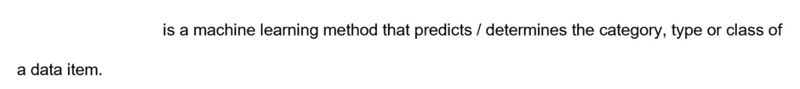



Classification

clustering

regression

### Question 30: Forecasting stock market index values based on macro economic changes is an example of what machine learning scenario?

Choose the correct answer

Classification

Clustering

Regression

### Question 31: Processing new tweets to categorize them as positive or negative is an example of what machine learning scenario?

Choose the correct answer

Clustering

Classification

Regression

### Question 32: Which machine learning type should you use to predict ice cream sales based on the weather forecast?

Choose the correct answer

Clustering

Classification

Regression

### Question 33: Which machine learning type should you use to determine the amount of credit to give to a customer?

Choose the correct answer

Classification

Clustering

Regression

### Question 34: Which machine learning type should you use to determine if a social media post has positive or negative sentiment?

Choose the correct answer

Classification

Clustering

Regression

### Question 35: Which machine learning type should you use to approve or reject a customer's application for credit?

Choose the correct answer

Clustering

Classification

Regression

### Question 36: To complete the following sentence, select the appropriate option from the drop-down menu.

Choose the correct options

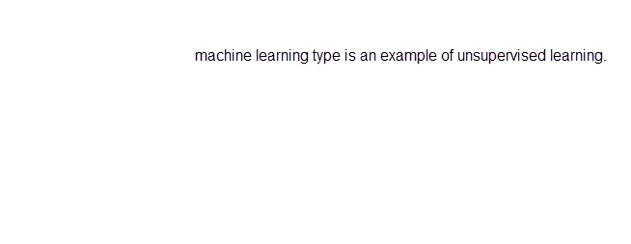



classification

clustering

Regression

### Question 37: To complete the following sentence, select the appropriate option from the drop-down menu.

Choose the correct options

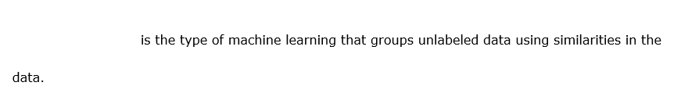



classification

clustering

regression

## Describe core machine learning concepts

### Question 38: Which two metrics can you use to evaluate classification machine learning models? Each correct answer presents a complete solution.

Choose the correct answers

Mean Absolute Error (MAE)

Precision

Recall

Average Distance to Cluster Center

 Previous

### Question 39: Which two metrics can you use to evaluate regression machine learning models? Each correct answer presents a complete solution.

Choose the correct answers

Number of Points

Coefficient of Determination

F-score

Root Mean Squared Error (RMSE)

### Question 40: You train a machine learning model on the flowers dataset to predict the type of the iris species. Sample records from the dataset are shown in the exhibit. What do Sepal Length and Flower Species represent in the dataset? To answer, select the appropriate options from the drop-down menus.

Choose the correct options



A)

1. Algorithm
2. Feature
3. Label

B)

1. Algorithm
2. Feature
3. Label

### Question 41: You need to hold back a dataset from model training so it can be used to estimate a model's prediction error while tuning its hyperparameters. Which dataset should you use?

Choose the correct answer

Training dataset

Testing dataset

Raw data

Validation dataset

### Question 42: You train a new machine learning model using a classification algorithm. You need to ensure that your model iterates over the whole dataset during the training process only a certain number of times. Which setting should you adjust?

Choose the correct answer

Epoch

Learning rate

Random seed

Batch size

### Question 43: In the evaluation of the classification model you get a value of 0.4 for the area under the curve (AUC) metrics. What does it mean?

Choose the correct answer

40 percent of data is allocated to training and 60 percent to testing.

60 percent of data is allocated to training and 40 percent to testing.

The model is performing worse than a random guess.

The model is performing better than a random guess.

### Question 44:

You are building a machine learning model to predict a person's income based on their height and age.   
  
The exhibit shows a sample from an income dataset.

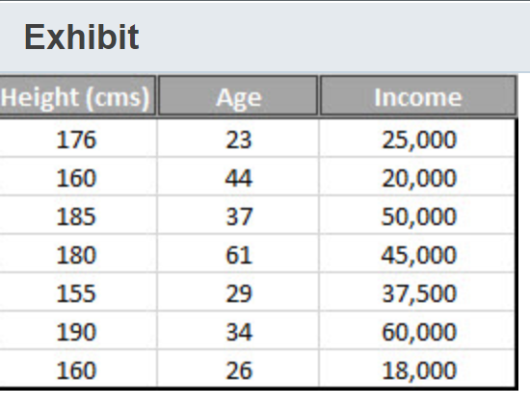  
  
What do the following columns in the dataset represent? To answer, select the appropriate options from the drop-down menus.

Choose the correct options

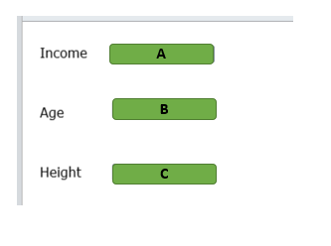

A)

1. Feature
2. Hyperparameter
3. label

B)

1. Feature
2. Hyperparameter
3. Label

C)

1. Feature
2. Hyperparameter
3. label

### Question 45: Which two datasets do you use to build a machine learning model? Each correct answer presents part of the solution.

Choose the correct answers

Training dataset

Azure Open Dataset

Validation dataset

Testing dataset

### Question 46: To complete the following sentence, select the appropriate option from the drop-down menu.

Choose the correct options



Pattern

Prediction

Probabilities

### Question 47: Which two metrics can you use to evaluate a classification machine learning model? Each correct answer presents a complete solution.

Choose the correct answers

Coefficient of determination

Maximal Distance to Cluster Center

F-score

Root mean squared error (RMSE)

Precision

### Question 48: Which two metrics can you use to evaluate a regression machine learning model? Each correct answer presents a complete solution.

Choose the correct answers

Average Distance to Cluster Center

Relative absolute error (RAE)

Area under the curve (AUC)

Precision

Coefficient of determination

### Question 49: You evaluate a machine learning model and it generates the matrix shown in the exhibit.

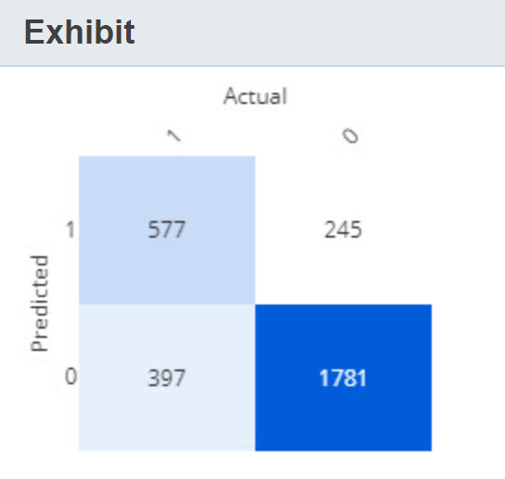  
  
For each of the following statements, select Yes if the statement is true. Otherwise, select No.

|  |  |  |
| --- | --- | --- |
| **Statement** | **Yes** | **No** |
| The machine learning model is a classification model. |  |  |
| There are 397 false positives. |  |  |
| There are 1781 true negatives. |  |  |

### Question 50: Which technique does each of these family of algorithms use when training a model? To answer, select the appropriate options from the drop-down menus.

Choose the correct options

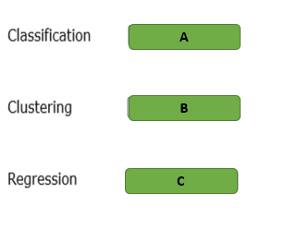

A)

1. Reinforcement
2. Supervised
3. Unsupervised

B)

1. Reinforcement
2. Supervised
3. Unsupervised

C)

1. Reinforcement
2. Supervised
3. Unsupervised

## Identify core tasks in creating a machine learning solution

### Question 51: What should you do to measure the accuracy of the predictions and assess model fit?

Choose the correct answer

Evaluate the model.

Detect languages.

Score the model.

Evaluate the probability function.

 Previous

### Question 52: To complete the sentence, select the appropriate option from the drop-down menu.

Choose the correct options

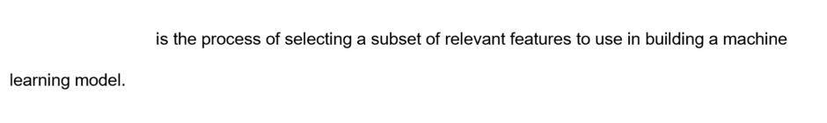

Feature selection

Cross-validation

Evolution

### Question 53: For each of the following statements about data splitting in machine learning, select Yes if the statement is true. Otherwise, select No.

|  |  |  |
| --- | --- | --- |
| **Statement** | **Yes** | **No** |
| You can divide a dataset using regular expression. |  |  |
| You can split a dataset for training/testing by rows. |  |  |
| You can split a dataset for training/testing by columns. |  |  |

### Question 54: Which data transformation method is used in machine learning to create a smaller dataset representative of the original massive dataset?

Choose the correct answer

Sampling

Normalization

Feature hashing

Splitting

### Question 55: To complete the following sentence, select the appropriate option from the drop-down menu.

Choose the correct options

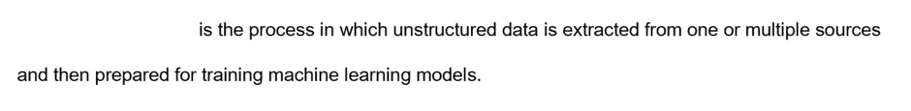

Data ingestion

Value clipping

Data export

### Question 56: Which two are types of distributed machine learning model training? Each correct answer presents a complete solution.

Choose the correct answers

Model parallelism

Data normalization

Data parallelism

Model evaluation

Model interpretability

### Question 57: To which two compute targets can you deploy a machine learning model as a web service? Each correct answer presents a complete solution.

Choose the correct answers

Azure Service Bus

Azure Container Instances. (ACI)

Azure Kubernetes Service. (AKS)

Azure IoT Hub

Azure Event Hub

### Question 58: To complete the following sentence, select the appropriate option from the drop-down menu.

Choose the correct options

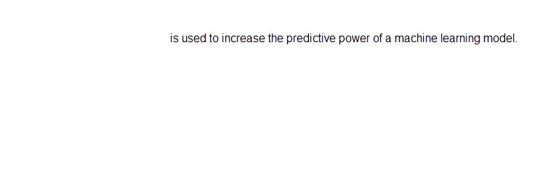

evaluation

Feature engineering

Feature selection

### Question 59: What should you do after training your model and prior to deploying it as a web service?

Choose the correct answer

Clone the training pipeline.

Create a compute cluster.

Evaluate the model.

Create an inference pipeline from the training pipeline.

### Question 60: You train a machine learning model. The model evaluation had low training error and high accuracy. You deploy the model and you see a high error rate when predicting new values. What should you do to improve predictions?

Choose the correct answer

Cross validate the model.

Normalize the data.

Add features.

Split the training data.

### Question 61: A dataset contains attributes that have values in different units with different ranges of values. Which data preprocessing method is used to transform the values into a common scale?

Choose the correct answer

Normalization

Binning

Substitution

Sampling

### Question 62: What should you do to measure the accuracy of a trained machine learning model?

Choose the correct answer

Score the model.

Summarize the data.

Normalize the data.

Create features.

### Question 63: Which compute target should you use for the development of machine learning models?

Choose the correct answer

Azure Container Instances (ACI)

Compute cluster

Azure Kubernetes Service (AKS)

Compute instance

## Describe capabilities of no-code machine learning with Azure Machine Learning:

### Question 64: You build a new pipeline in Azure Machine Learning Designer to predict potential flight delays. 70 percent of the flight delays data is to be allocated to training, and the remaining 30 percent to testing. Which modules should you use to complete the pipeline configuration? To answer, drag the appropriate module name to the relevant slots. A module name may be used once, more than once, or not at all.

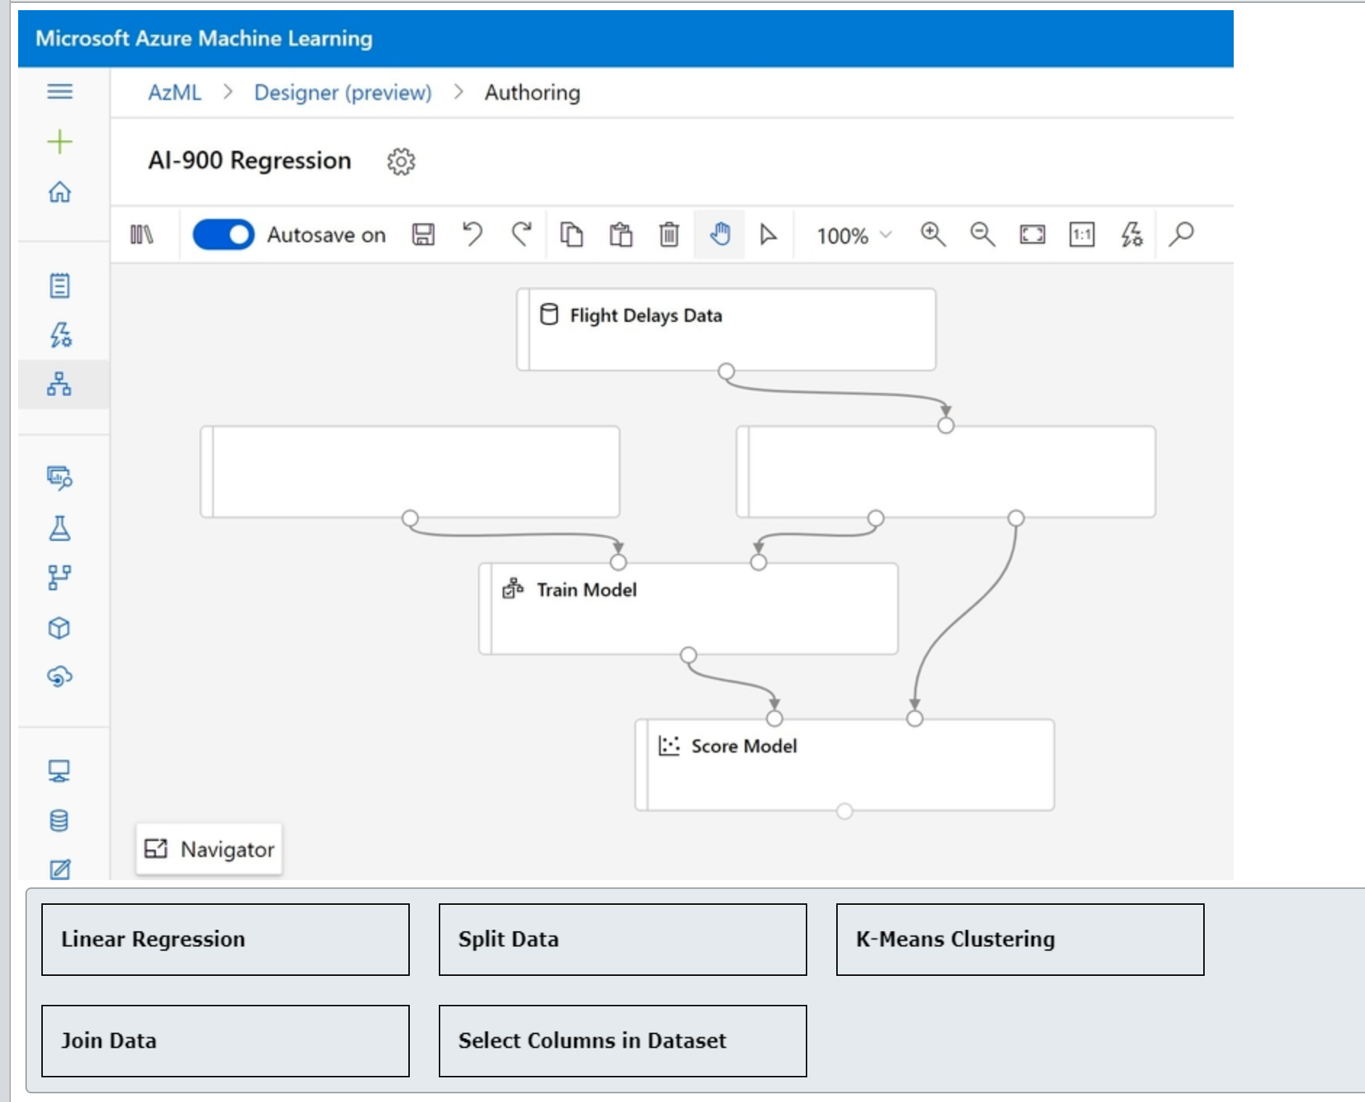

### Question 65: You build a new pipeline in Azure Machine Learning Designer to predict from the census data whether a person will earn more or less than $50,000 per year. You need to populate the records with the empty numeric fields with the column’s mean values. What modules should you use to complete the pipeline configuration? To answer, drag the appropriate module names to the relevant slots. A module name may be used once, more than once, or not at all.

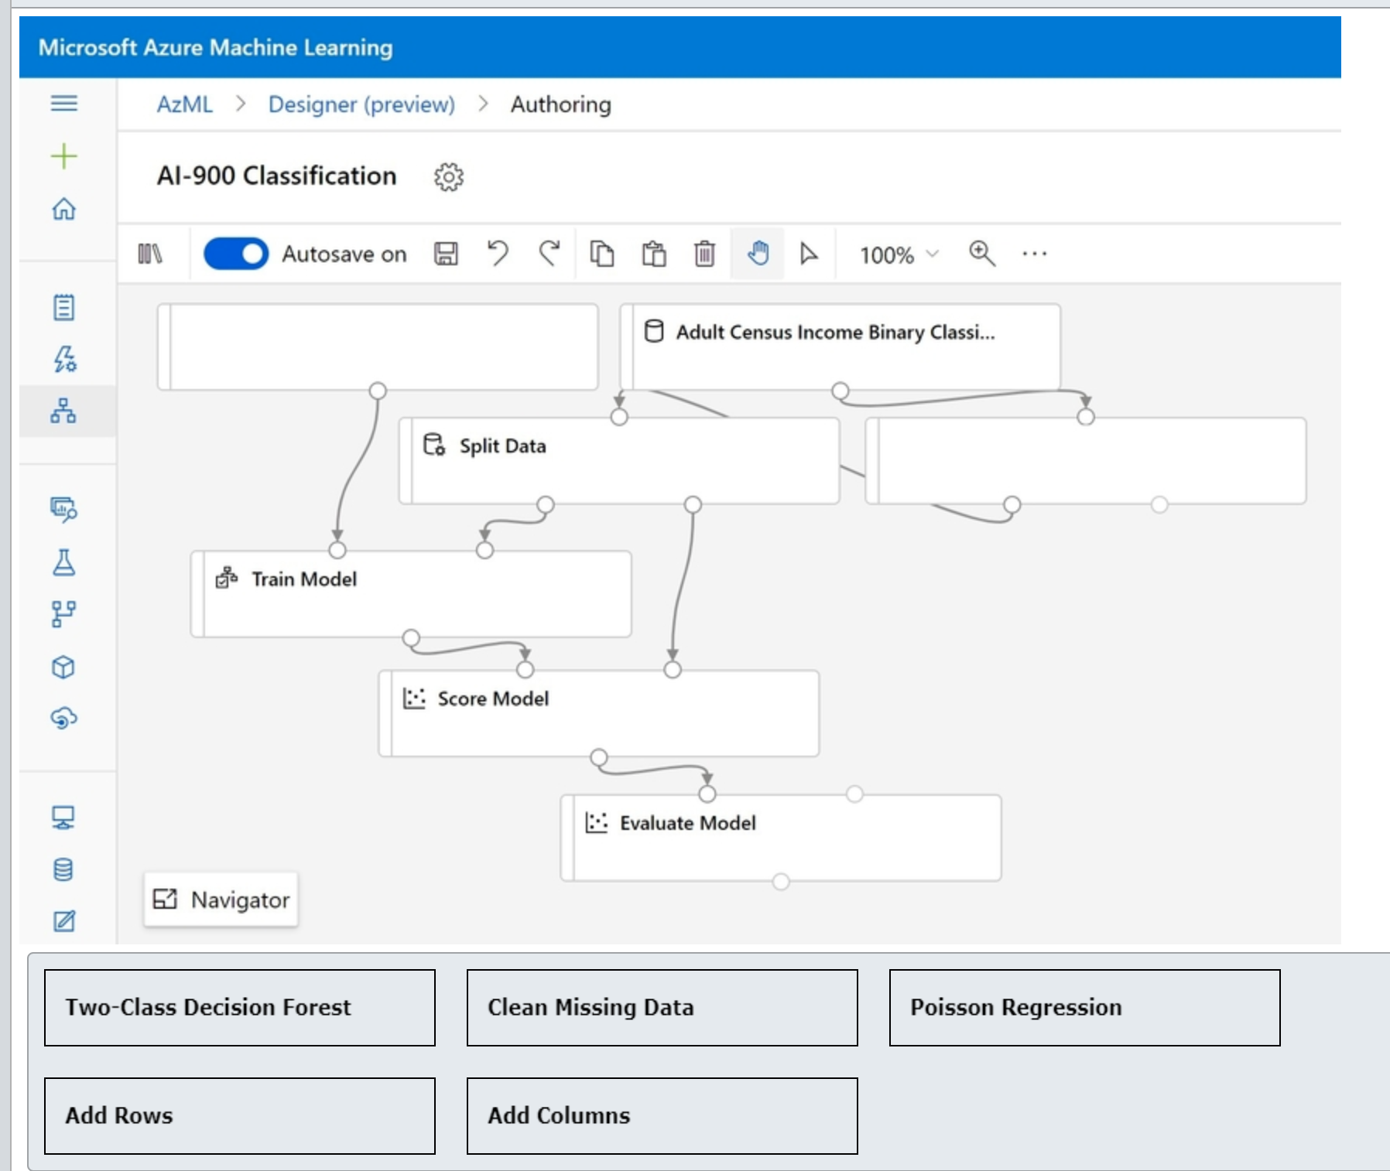

### Question 66: For each of the following statements about Azure Machine Learning (Azure ML) designer, select Yes if the statement is true. Otherwise, select No.

|  |  |  |
| --- | --- | --- |
| **Statement** | **Yes** | **No** |
| You can connect datasets directly to each other. |  |  |
| You can connect modules directly to each other. |  |  |
| Pipeline endpoint can be used to send and receive data in real time. |  |  |

### Question 67: What should you configure in Automated Machine Learning (AutoML) settings to ensure that it follows the Transparency principle of Responsible AI?

Choose the correct answer

Enable Explain best model option.

Set Primary metric to Accuracy.

Set Validation type to Auto.

Select RandomForest in Blocked algorithms list.

### Question 68: Which two data source types are supported in Azure Automated Machine Learning (AutoML)? Each correct answer presents a complete solution.

Choose the correct answers

File Dataset

Tabular Dataset

Azure Cosmos DB

Azure Cache for Redis

Azure Database for MySQL

### Question 69: To complete the following sentence, select the appropriate option from the drop-down menu.

Choose the correct options



Automated machine learning (AutoML)

Normalization

Feature engineering

### Question 70: Which two types of dataset can you register and use to train your Automatic Machine Learning (AutoML) model? Each correct answer presents a complete solution.

Choose the correct answers

SQL Query

Folder

Azure Blob Container

File

Tabular

### Question 71: Your dataset has multiple numeric features whose values are on different scales. Which module should you add to the training pipeline in the Azure Machine Leraning (ML) designer to mitigate bias?

Choose the correct answer

Normalize Data

Clip Values

Clean Missing Data

Select Columns in Dataset

### Question 72: You plan to use Azure Machine Learning designer to create a classification machine learning model. Which Azure Machine Learning workspace edition should you use?

Choose the correct answer

Enterprise

Production

Basic

Dev-test

### Question 73: You use Automated machine learning (ML) to find the best model for your data. Which option should you use to interpret and provide transparency for the model selected?

Choose the correct answer

Target column

Forecast horizon

Enable deep learning

Explain best model

### Question 74: For each of the following statements, select Yes if the statement is true. Otherwise, select No.

|  |  |  |
| --- | --- | --- |
| **Statement** | **Yes** | **No** |
| The Azure Machine Learning studio supports both no-code and code-first experiences. |  |  |
| The Azure Machine Learning studio can create and run Jupyter notebooks. |  |  |
| The Azure Machine Learning studio can create models using C# and .NET. |  |  |

### Question 75: For each of the following statements, select Yes if the statement is true. Otherwise, select No.

|  |  |  |
| --- | --- | --- |
| **Statement** | **Yes** | **No** |
| Automated machine learning (AutoML) can train and tune a classification model. |  |  |
| Automated machine learning (AutoML) can train and tune a clustering model. |  |  |
| Automated machine learning (AutoML) can train and tune a regression model. |  |  |

### Question 76: You create a training pipeline in Azure Machine Learning designer. You need to complete the pipeline. Which modules should you use to complete the pipeline? To answer, drag the appropriate module to the relevant slots. A module may be used once, more than once, or not at all.

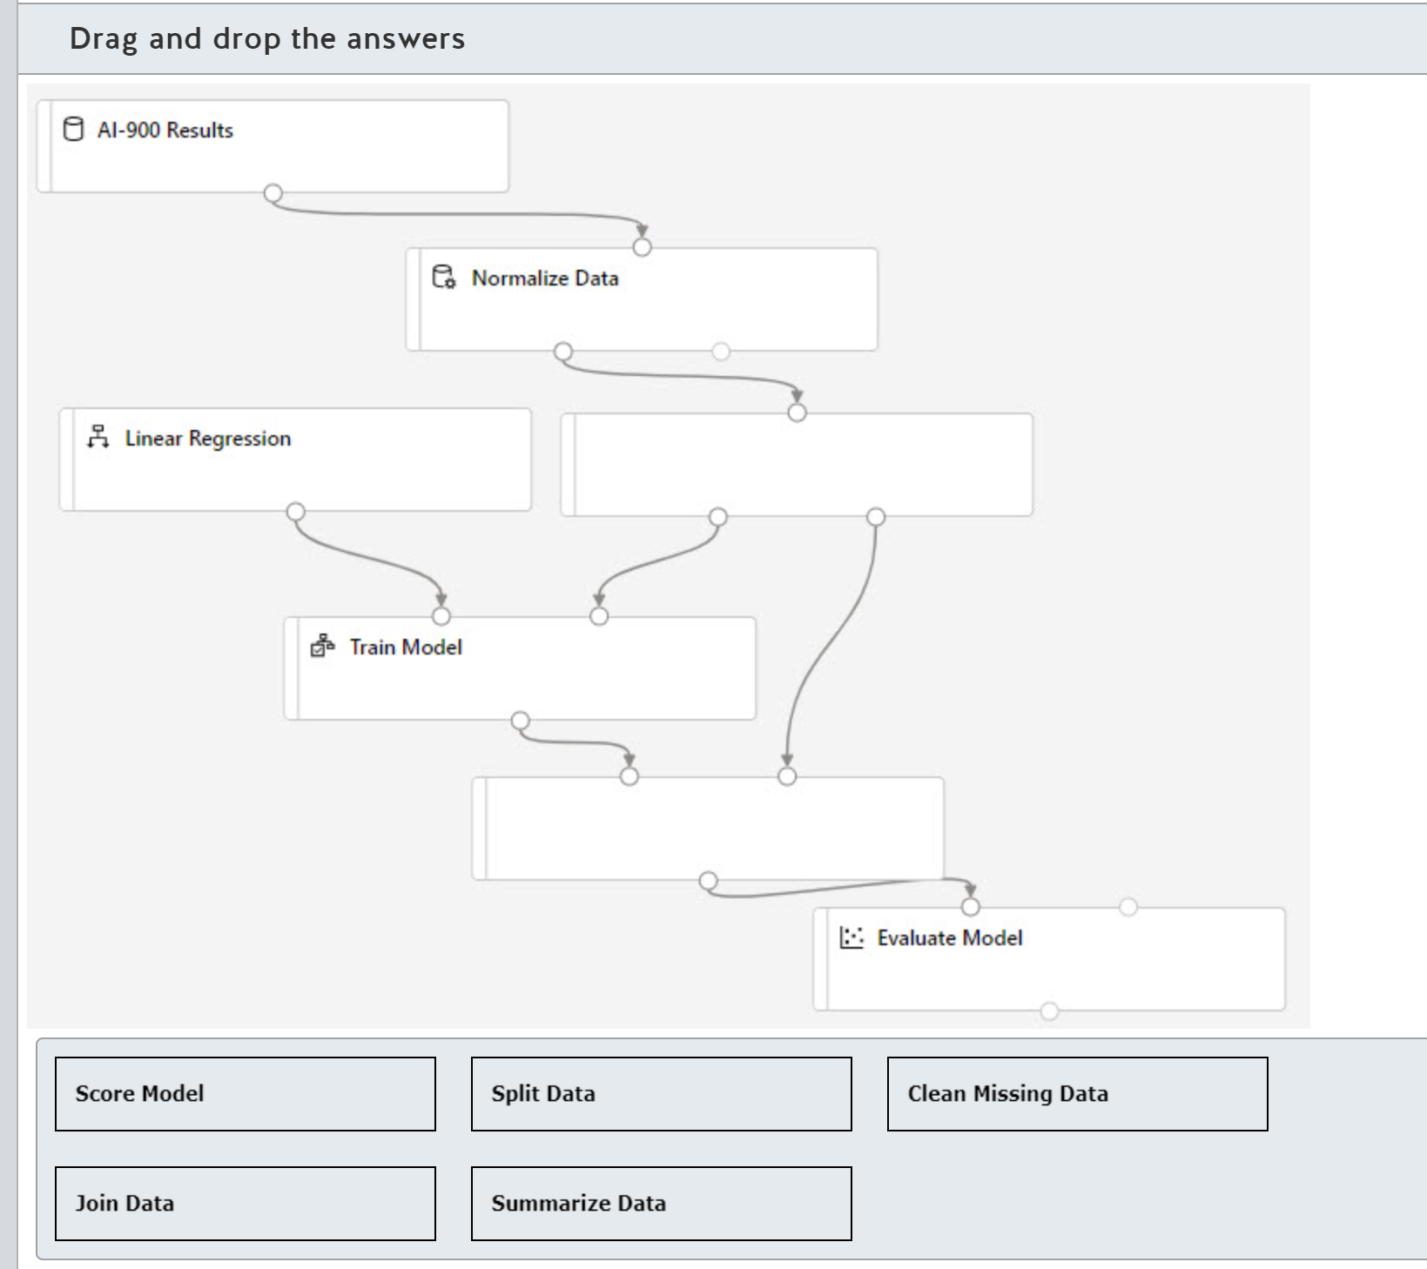

### Question 77: You create a real-time inference pipeline from a training pipeline in Azure Machine Learning designer. You need to complete the inference pipeline. Which modules should you use to complete the pipeline? To answer, drag the appropriate module to the relevant slots. A module may be used once, more than once, or not at all.

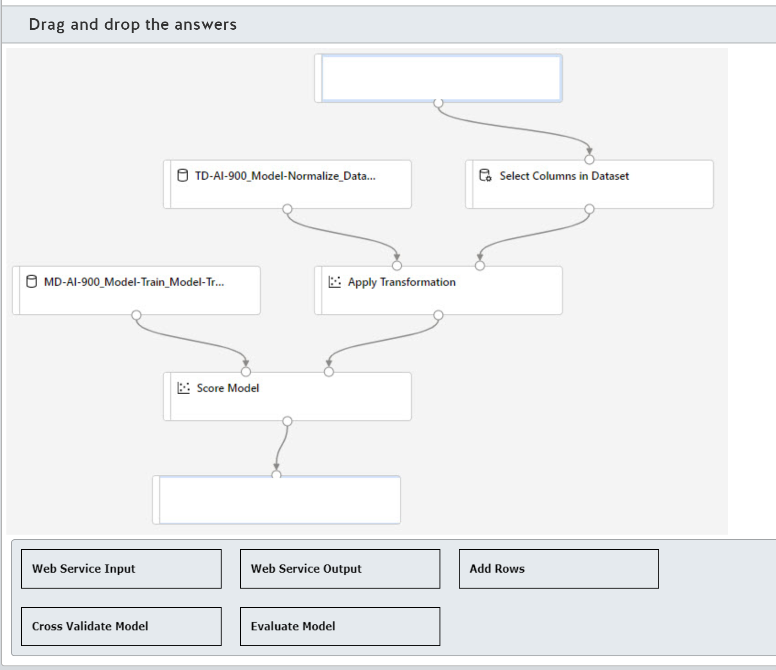

# Describe features of computer vision workloads on Azure

## Identify common types of computer vision solution:

### Question 78

Question 78: Match the Computer Vision solution to a scenario.  
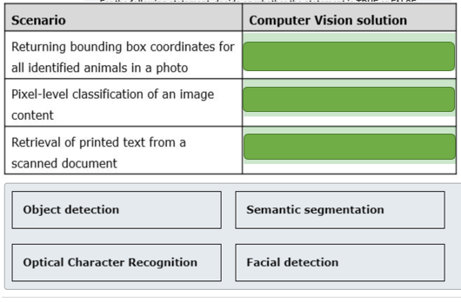  
To answer, drag the appropriate computer vision solution to each relevant scenario. A computer vision solution may be used once, more than once, or not at all.

### Question 79

Question 79: To complete the following sentence, select the appropriate option from the drop-down menu.

Choose the correct options



Image classification

Object detection

Special character recognition

Semantic segmentation

### Question 80: For which two of these requirements should you use object detection? Each correct answer presents a complete solution.

Choose the correct answers

Detecting the color scheme

Identifying individual objects

Associating each pixel in the image with a label

Identifying the location of visual features

Identifying people

### Question 81: In which of the following scenarios would you use semantic segmentation?

Choose the correct answer

Tagging famous people in an image gallery

Quality control on a manufacturing line

Driving autonomous vehicles

Recognizing customers in a retail store

### Question 82: Which of the following is a scenario where you would need to use an optical character recognition solution?

Choose the correct answer

Validating identity for access to business premises

Processing and validating invoices

Evaluating compliance with building safety regulations

Identifying products in a warehouse location

### Question 83: For each of the following statements about facial detection, select Yes if the statement is true. Otherwise, select No.

|  |  |  |
| --- | --- | --- |
| **Statement** | **Yes** | **No** |
| Facial detection can determine whether a person is wearing glasses. |  |  |
| Facial detection requires a full-frontal image. |  |  |
| Facial detection can determine the emotion of a person. |  |  |

### Question 84: Match the computer vision type to the scenario. To answer, drag the appropriate type to each scenario. A type may be used once, more than once, or not at all.

Drag and drop the answers

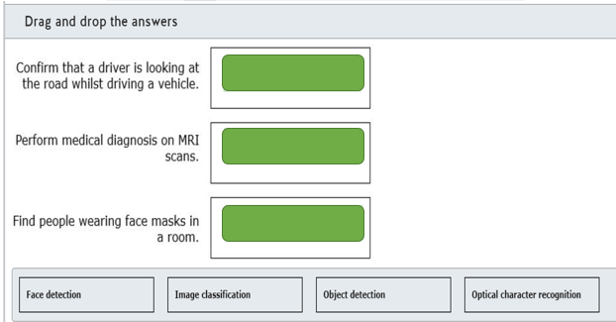

### Question 85: Match the Computer Vision solution to a scenario. To answer, drag the appropriate computer vision solution to each relevant scenario. A computer vision solution may be used once, more than once, or not at all.

Drag and drop the answers

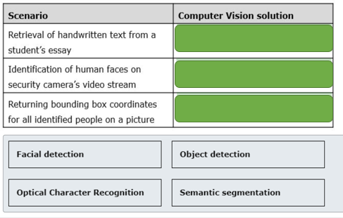

### Question 86: To complete the following sentence, select the appropriate option from the drop-down menu.

Choose the correct options

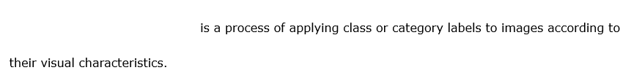



Image classification

Object detection

Named entity recognition (NER)

### Question 87: For each of the following statements about facial detection, select Yes if the statement is true. Otherwise, select No.

|  |  |  |
| --- | --- | --- |
| **Statement** | **Yes** | **No** |
| Photos taken at an extreme face angle can positively affect the facial detection process. |  |  |
| Wearing sunglasses can negatively affect the facial detection process. |  |  |
| A slower shutter speed of the video camera improves performance of the facial detection solution. |  |  |

### Question 88: Which scenario is an example of the use of Optical Character Recognition (OCR)?

Choose the correct answer

Detecting people and animals on a video feed of a security camera

Extracting handwritten text from the scanned copies of cheques

Recognizing speakers from audio recordings

Detecting abnormalities in a device telemetry

### Question 89: Which scenario is an example of the use of object detection?

Choose the correct answer

Finding answers on customer’s questions in a bot dialog screen

Tracking seasonal migration of animals from drone camera images

Verifying employees based on their voices

Extracting address details from scanned postal envelopes

## Identify Azure tools and services for computer vision tasks

### Question 90: For each of the following statements about the Computer Vision service, select Yes if the statement is true. Otherwise, select No.

|  |  |  |
| --- | --- | --- |
| **Statement** | **Yes** | **No** |
| The Computer Vision service can moderate adult content. |  |  |
| The Computer Vision service can extract printed or handwritten text from images. |  |  |
| The Computer Vision service can translate text in an image. |  |  |

### Question 91: Which two project types can you choose in the Custom Vision service? Each correct answer presents a complete solution.

Choose the correct answers

Semantic segmentation

Facial Recognition

Object Detection

Classification

K-Means Clustering

### Question 92: Match the requirement to the service. To answer, drag the appropriate service to each scenario. A service may be used once, more than once, or not at all.

Drag and drop the answers

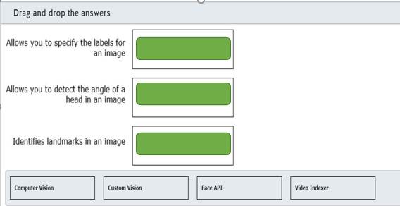

### Question 93: Match the requirement to the face recognition operation. To answer, drag the appropriate operation to each scenario. An operation may be used once, more than once, or not at all.

Drag and drop the answers

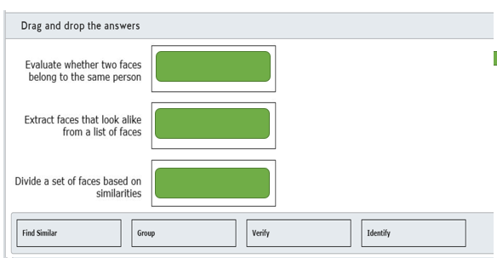

### Question 94: Which of the following services would you use to find the recipe for a food dish in an image?

Choose the correct answer

Bing Visual Search

Text Analytics

Computer Vision

Custom Vision

### Question 95: To complete the following sentence, select the appropriate option from the drop-down menu.

Choose the correct options

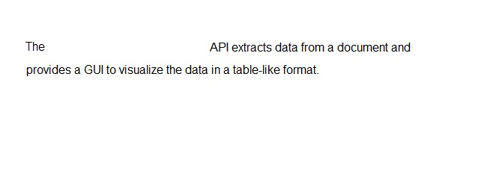

From Recognizer

Computer Vision OCR

Computer Vision Read

### Question 96: You need to use Azure cognitive service to automate data extraction from scanned copies of sales receipts minimizing development efforts. What Azure cognitive service should you use?

Choose the correct answer

Custom Vision

Form Recognizer

Computer Vision

Text Analytics

### Question 97: Which two Azure cognitive services can be used to analyze faces within an image? Each correct answer presents a complete solution.

Choose the correct answers

Form Recognizer

Computer Vision

Personalizer

Face

Text Analytics

### Question 98: You need to build a butterfly image classifier using your own set of images and labels. Which Azure cognitive service should you use?

Choose the correct answer

Video Indexer

Custom Vision

Computer Vision

Bing Image Search

### Question 99: For each of the following statements about Form Recognizer, select Yes if the statement is true. Otherwise, select No.

|  |  |  |
| --- | --- | --- |
| **Statement** | **Yes** | **No** |
| Prebuilt business card model can extract information from business cards in English. |  |  |
| Prebuilt receipt model can extract information from sales receipts in French. |  |  |
| Custom model can be trained to extract information from custom forms in Spanish. |  |  |

### Question 100: Match the Azure service to a scenario. To answer, drag the appropriate Azure service to each use case scenario. An Azure service may be used once, more than once, or not at all.

Drag and drop the answers

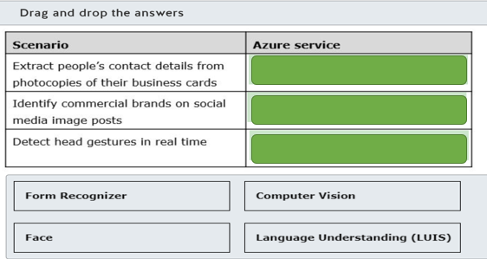

### Question 101: You need to identify dominant colors in online images to check if they influence the popularity of the featured products. Which Azure cognitive service should you use?

Choose the correct answer

Form Recognizer

Personalizer

Computer Vision

Custom Vision

# Describe features of Natural Language Processing (NLP) workloads on Azure

## Identify features of common NLP Workload Scenarios

### Question 102: For each of the following statements about natural language processing, select Yes if the statement is true. Otherwise, select No.

|  |  |  |
| --- | --- | --- |
| **Statement** | **Yes** | **No** |
| Key phrase extraction performs better on smaller amounts of text. |  |  |
| Sentiment analysis performs better on smaller amounts of text. |  |  |
| Speech Synthesis Markup Language (SSML) is based on JSON format. |  |  |

### Question 103:

For each of the following statements about Sentiment Analysis, select Yes if the statement is true. Otherwise, select No.

|  |  |  |
| --- | --- | --- |
| **Statement** | **Yes** | **No** |
| Sentiment Analysis returns sentiment labels and scores for the entire document. |  |  |
| Sentiment Analysis returns sentiment labels and scores for each sentence within a document. |  |  |
| Confidence scores range from -1 to 1. |  |  |

### Question 104: AI solution identifies the main points in a set of blog posts. Which Natural Language Processing (NLP) workload is this an example of?

Choose the correct answer

Sentiment analysis

Named entity recognition

Key phrase extraction

Speech recognition

### Question 105: AI solution processes customer feedback and classifies it as positive, neutral or negative. Which Natural Language Processing (NLP) workload is this an example of?

Choose the correct answer

Sentiment analysis

Speech translation

Named entity recognition

Speech synthesis

### Question 106: Match the natural language processing (NLP) workload to a scenario. To answer, drag the appropriate NLP workload to each relevant scenario. An NLP workload may be used once, more than once, or not at all.

Drag and drop the answers

### 

### Question 107: To complete the sentence, select the appropriate option from the drop-down menu.

Choose the correct options

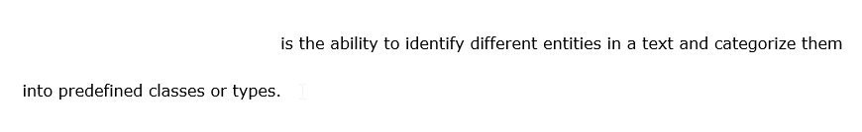

Language detection

Named entity recognition

Speech translation

### Question 108: To complete the following sentence, select the appropriate option from the drop-down menu.

Choose the correct options

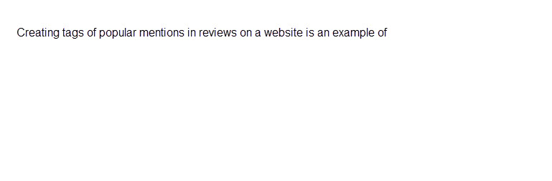

Entity recognition

Key phrase extraction

Sentiment analysis

### Question 109: Which two of the following can be found in a text document by using entity recognition? Each correct answer presents a complete solution.

Choose the correct answers

Dates and times of a day

Intent and actions

Passport number

Main talking points

Emotion expressed

### Question 110: Which requirement would require you to use sentiment analysis?

Choose the correct answer

Find the use of brand names in documents.

Extract brand information from documents.

Transcribe the recording of a marketing presentation into text.

Analyze social media for a brand.

### Question 111:

For each of the following statements about language modeling, select Yes if the statement is true. Otherwise, select No.

|  |  |  |
| --- | --- | --- |
| **Statement** | **Yes** | **No** |
| Language modeling can determine the emotion in a text statement. |  |  |
| Language modeling can discover the meaning in a text statement. |  |  |
| Language modeling can detect the language the text is written in. |  |  |

### Question 112: To complete the following sentences, select the appropriate options from the drop-down menus.

Choose the correct options

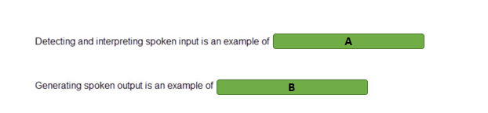

A)

1. Optical character recognition (OCR)
2. Speech recognition
3. Speech synthesis
4. Translation

B)

1. Optical character recognition (OCR)
2. Speech recognition
3. Speech synthesis
4. Translation

### Question 113: Which two of these sources can you translate from one language into another? Each correct answer presents a complete solution.

Choose the correct answers

Handwriting

Video

Speech

Image

Text

### Question 114: Match the natural language processing workload to a scenario. To answer, drag the appropriate workload to each scenario. A workload may be used once, more than once, or not at all.

Drag and drop the answers

## 

## Identify Azure tools and services for NLP workloads

### Question 115: You need to build an AI solution that can identify and disambiguate entities in your input texts using Wikipedia as its knowledge base. What Azure cognitive service should you use?

Choose the correct answer

Custom Vision

Bing Autosuggest

Form Recognizer

Text Analytics

### Question 116: You need to build an AI solution that can determine the broader meaning of a user's intentions from their utterances. Which Azure cognitive service should you use?

Choose the correct answer

Form Recognizer

Language Understanding Intelligence Service (LUIS)

Bing Local Business Search

Text Translator

### Question 117: You need to enhance your chat application’s functionality to enable English to Korean translation in near real-time. Which Azure cognitive service should you use?

Choose the correct answer

Text Translator

Language Understanding Intelligence Service (LUIS)

Form Recognizer

Speech Translator

### Question 118: Move the appropriate Azure service to the answer area to match it with the relevant use in each scenario. An Azure service may be used once, more than once, or not at all.

Drag and drop the answers

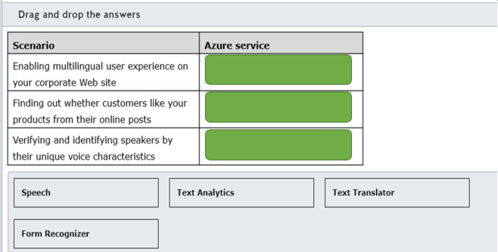

### Question 119: Move the appropriate Azure service to the answer area to match it with the relevant use in each scenario. An Azure service may be used once, more than once, or not at all.

Drag and drop the answers

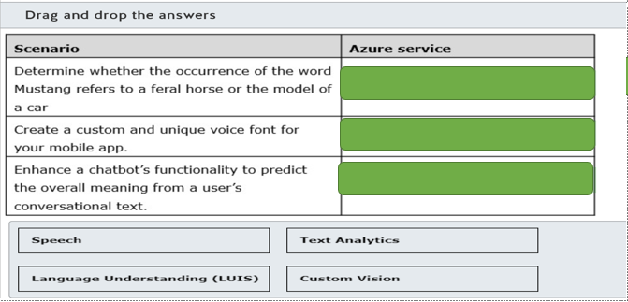

### Question 120: For each of the following statements, select Yes if the statement is true. Otherwise, select No.

|  |  |  |
| --- | --- | --- |
| **Statement** | **Yes** | **No** |
| To use the Speech service, you need to build a custom speech model. |  |  |
| The Speech service can transcribe audio streams in real time. |  |  |
| The Speech service can transcribe audio files asynchronously. |  |  |

### Question 121: Which two Azure cognitive services can you combine to recognize intents in voice commands? Each correct answer presents part of the solution.

Choose the correct answers

Language Understanding

Text Translator

Speaker Recognition

Form Recognizer

Speech

### Question 122: For each of the following statements about the Azure Cognitive Services Text Analytics service, select Yes if the statement is true. Otherwise, select No.

|  |  |  |
| --- | --- | --- |
| **Statement** | **Yes** | **No** |
| The results from the Key Phrases operation in Text Analytics includes a confidence score between 0 and 1. |  |  |
| The Text Analytics API can be used with C#. |  |  |
| Text Analytics can be used by Power App canvas apps to analyze text. |  |  |

### Question 123: What information do you need to use in a published Language Understanding model to find the meaning in a text statement?

Choose the correct answer

Endpoint and key of a Text Analytics resource

Subscription ID and resource ID of a Language Understanding Intelligence Service (LUIS) resource

App Id, Authoring endpoint and Authoring key of a Language Understanding Intelligence Service (LUIS) app

App Id, Prediction endpoint and Prediction key of a Language Understanding Intelligence Service (LUIS) app

### Question 124: Match the requirement to a Speech service API. To answer, drag the appropriate API to each requirement. An API may be used once, more than once, or not at all.

Drag and drop the answers

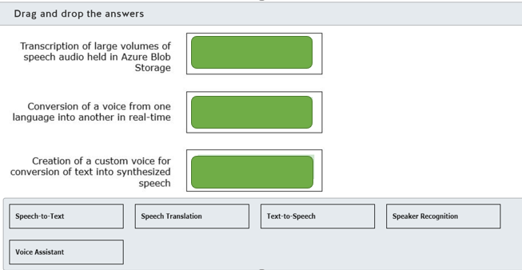

### Question 125: To complete the following sentence, select the appropriate option from the drop-down menu.

Choose the correct options

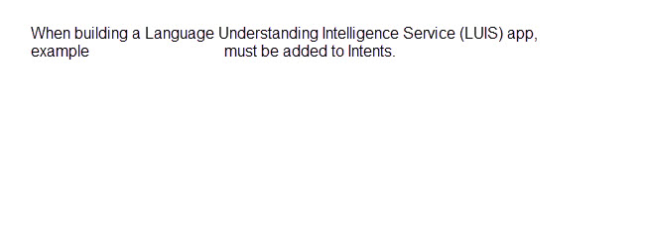

Entities

Features

Utterances

### Question 126: Match the requirement to a Language Understanding Intelligence Service (LUIS) prebuilt model type. To answer, drag the appropriate prebuilt model to each requirement. A prebuilt model may be used once, more than once, or not at all.

Drag and drop the answers

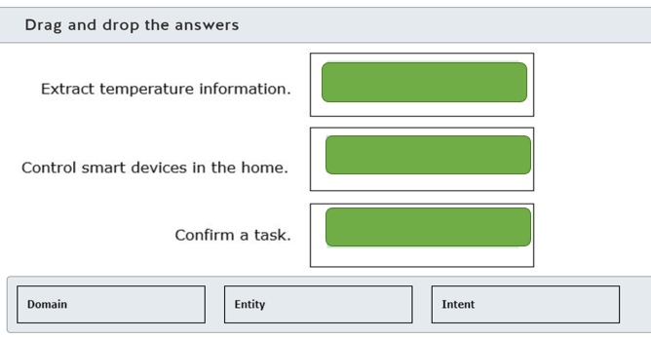

### Question 127: For each of the following statements about the Translator service, select Yes if the statement is true. Otherwise, select No.

|  |  |  |
| --- | --- | --- |
| **Statement** | **Yes** | **No** |
| The Translator service uses Statistical Machine Translation (SMT) technology. |  |  |
| The Translator service can simultaneously translate from one language into multiple other languages. |  |  |
| The Translator service supports translation into language variants such as French and Canadian French. |  |  |

# Describe features of conversational AI workloads on Azure

## Identify common use cases for conversational AI

### Question 128: A customer calling a support line number gets an AI-generated voice prompt with options to choose from. Which conversational AI is this an example of?

Choose the correct answer

Telephone voice menu

Webchat bot

Personal digital assistant

### Question 129: An app is embedded in a travel site to interact with online customers and help with the real-time booking of their trips. Which conversational AI is this an example of?

Choose the correct answer

Webchat bot

Telephone voice menu

Personal digital assistant

### Question 130: To complete the following sentence, select the appropriate option from the drop-down menu.

Choose the correct options

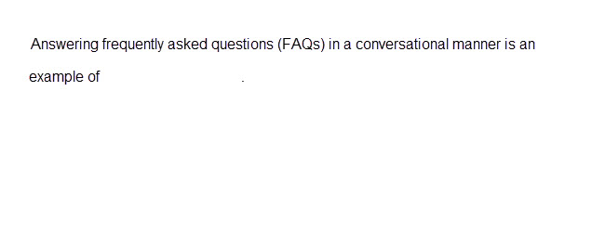

Object detection

Speech recognition

Webchat bots

### Question 131: What is the most common use of a bot?

Choose the correct answer

Identifying the main points in a document uploaded by a customer

Interpreting an image uploaded by a customer

Prioritizing customer emails by performing statistical analysis of the email's content

Providing first-line automated customer service to customers across multiple channels

### Question 132: In which two scenarios could you use a bot? Each correct answer presents a complete solution.

Choose the correct answers

Assembly of vehicles on a production line

Customer online ordering

Autonomous vehicles

Human Resources-related questions from an employee

### Question 133: To complete the following sentence, select the appropriate option from the drop-down menu.

Choose the correct options

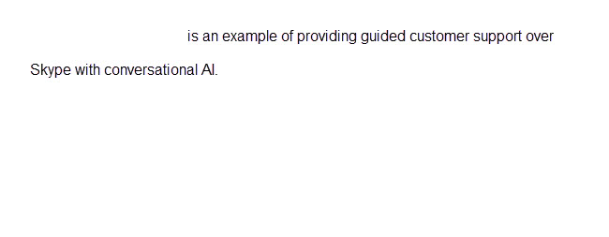

Personal digital assistant

Telephone voice menu

Web chat

### Question 134: For each of the following statements about personal digital assistants, select Yes if the statement is true. Otherwise, select No.

|  |  |  |
| --- | --- | --- |
| **Statement** | **Yes** | **No** |
| A personal digital assistant has knowledge of a user's needs and preferences. |  |  |
| A personal digital assistant acts on a user's behalf to perform intelligent actions. |  |  |
| A personal digital assistant has text only responses. |  |  |

### Question 135: Match the conversational AI workload to the scenario. To answer, drag the appropriate workload to each scenario. A workload may be used once, more than once, or not at all.

Drag and drop the answers

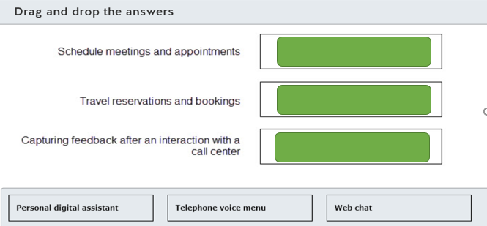

### Question 136: An AI solution on your smartphone can understand your voice command and send text messages while you drive a car. Which conversational AI is this an example of?

Choose the correct answer

Telephone voice menu

Personal digital assistant

Webchat bot

### Question 137: To complete the sentence, select the appropriate option from the drop-down menu.

Choose the correct options

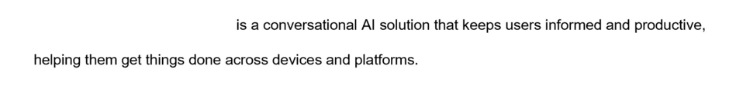

Telephone voice menu

Personal digital assistant

Webchat bot

### Question 138: Match the conversational AI solution to a scenario. To answer, drag the appropriate conversational AI solution to each relevant scenario. A conversational AI solution may be used once, more than once, or not at all.

Drag and drop the answers

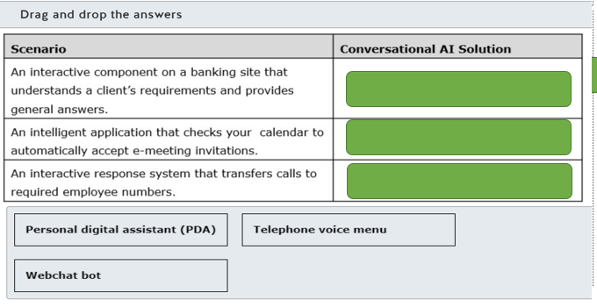

### Question 139: For each of the following statements about a telephone voice menu, select Yes if the statement is true. Otherwise, select No.

|  |  |  |
| --- | --- | --- |
| **Statement** | **Yes** | **No** |
| The caller can interact with a telephone voice menu via the phone keypad. |  |  |
| The caller can interact with a telephone voice menu via speech recognition. |  |  |
| The caller needs to know the recipient’s extension number to get connected. |  |  |

## Identify Azure services for conversational AI

### Question 140: In which two ways could you natively populate a QnA Maker knowledge base? Each correct answer presents a complete solution.

Choose the correct answers

Using a SharePoint list

Using a SQL database

Using a PDF document

Manually adding question and answer pairs

### Question 141: Which two Azure resources are created when a new QnA Marker service is created? Each correct answer presents part of the solution.

Choose the correct answers

Azure Key Vault

Web App Bot

App Service

Azure Cognitive Search

### Question 142: Which file format do you use for uploading a chit-chat personality to a QnA Maker knowledge base?

Choose the correct answer

XLS

PDF

CSV

TSV

### Question 143: Match the Azure Bot Service tool to the requirement. To answer, drag the appropriate tool to each requirement. A tool may be used once, more than once, or not at all.

Drag and drop the answers

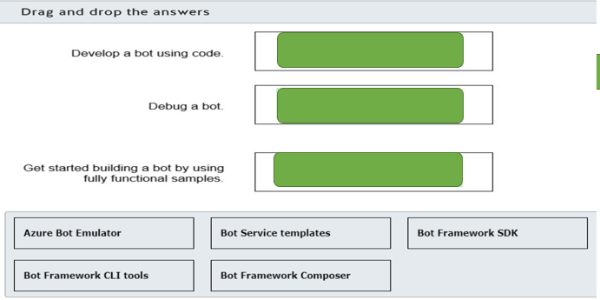

### Question 144: To complete the following sentence, select the appropriate option from the drop-down menu.

Choose the correct options

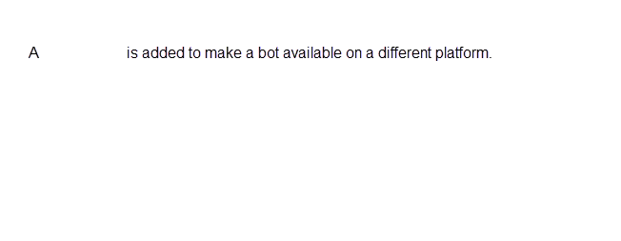

Channel

Skill

turn

### Question 145: For each of the following statements about Azure Bot Services, select Yes if the statement is true. Otherwise, select No.

|  |  |  |
| --- | --- | --- |
| **Statement** | **Yes** | **No** |
| A bot created with the Azure Bot Framework SDK can be integrated with Language Understanding (LUIS). |  |  |
| A bot created with the Azure Bot Framework SDK can be integrated with QnA Maker. |  |  |
| A bot created with the Azure Bot Framework SDK can be integrated with Power Virtual Agents. |  |  |

### Question 146: For each of the following statements about the QnA Maker knowledge base, select Yes if the statement is true. Otherwise, select No.

|  |  |  |
| --- | --- | --- |
| **Statement** | **Yes** | **No** |
| The QnA Maker app can only use one knowledge base. |  |  |
| A knowledge base supports multiple languages. |  |  |
| A knowledge base consists of question and answer pairs. |  |  |

### Question 147: Match each Azure resource to a purpose. To answer, drag the appropriate Azure resource to each purpose within the QnA Maker app. An Azure resource may be used once, more than once, or not at all.

Drag and drop the answers

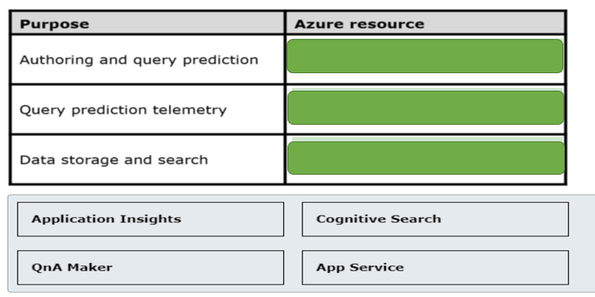

### Question 148: Which two Azure cognitive services should you combine so that your chatbot can determine user’s intentions and find answers from a custom knowledge base? Each correct answer presents part of the solution.

Choose the correct answers

QnA Maker

Language Understanding Intelligence Service (LUIS)

Text Translator

Speaker Recognition

Form Recognizer

### Question 149: For each of the following statements about skills in the Bot Framework, select Yes if the statement is true. Otherwise, select No.

|  |  |  |
| --- | --- | --- |
| **Statement** | **Yes** | **No** |
| A skill is a bot. |  |  |
| A skill manifest is an XML file. |  |  |
| Users can interact with a root bot. |  |  |

### Question 150: Which channel is automatically configured for a bot that was created with the Framework Bot Service?

Choose the correct answer

Skype

Email

Microsoft Teams

Web Chat

### Question 151: For each of the following statements about Bot Framework Composer, select Yes if the statement is true. Otherwise, select No.

|  |  |  |
| --- | --- | --- |
| **Statement** | **Yes** | **No** |
| Composer is an open source solution. |  |  |
| Composer is a command line program. |  |  |
| Composer can publish bots to Azure Web App and Azure Functions. |  |  |